P Project Report Template



TITLE: JOB TRACKING APPLICATION

1. **INTRODUCTION** 
   1. Overview

Create a CRM application which helps the applicant to track no of jobs he applied and help him to find the job posted by the various recruiters find the best attributes to be involved to run the process in a smooth way and easily to track

* 1. Purpose

An ATS Allows recruiters to match job requisitions to the job posting sites and the social media channel most appropriate for specific candidates . An ATS also maximizes visibility for internal job boards.

**2. Problem Definition and design thinking**  2.1 Empathy Map

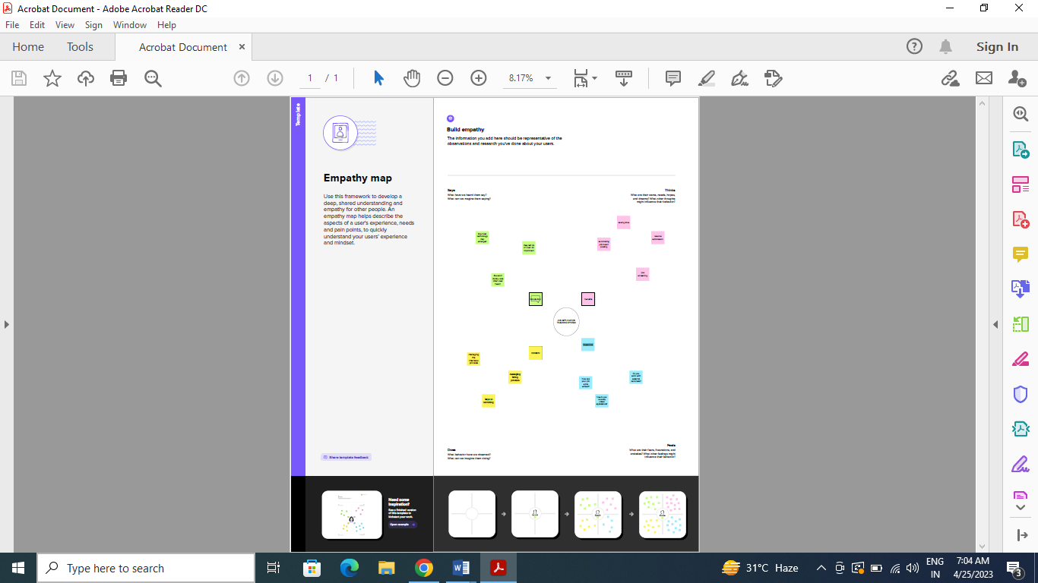

**2.2 Ideation and Brainstorming Map**

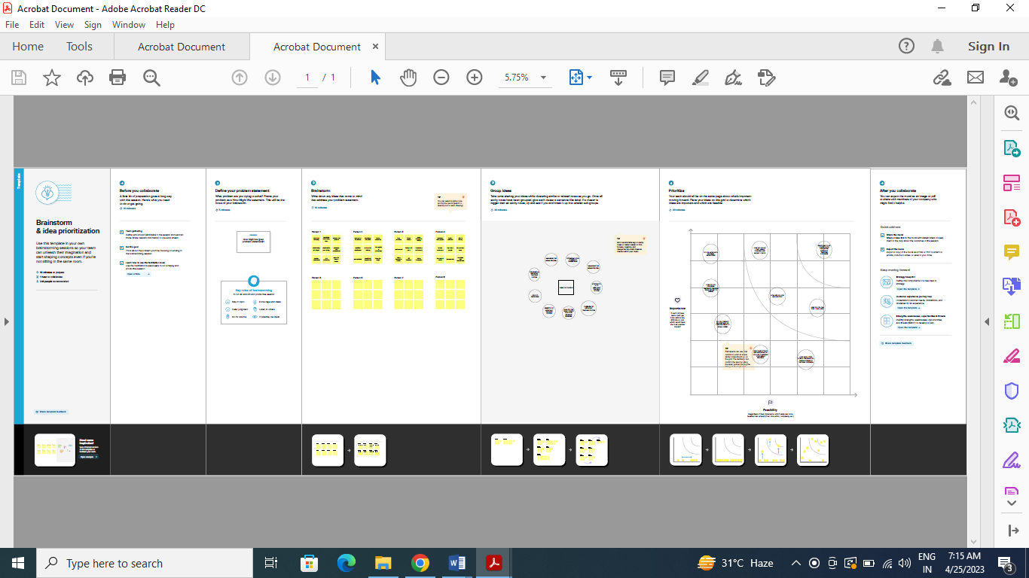

Data Model:

|  |  |
| --- | --- |
| **Object name** | **Fields in the Object** |
| obj1 | |  |  | | --- | --- | | Field label | Data type | | Jobs Number | Auto Number | | Owner | Look up | |

|  |  |  |  |  |  |  |  |
| --- | --- | --- | --- | --- | --- | --- | --- |
| obj2 | |  |  | | --- | --- | | Field label | Data type | | Owner | Lookup | | Recruiter Number | Auto Number | |

**Activity & Screenshot**

Attach the screenshots of your project activity along with the description.

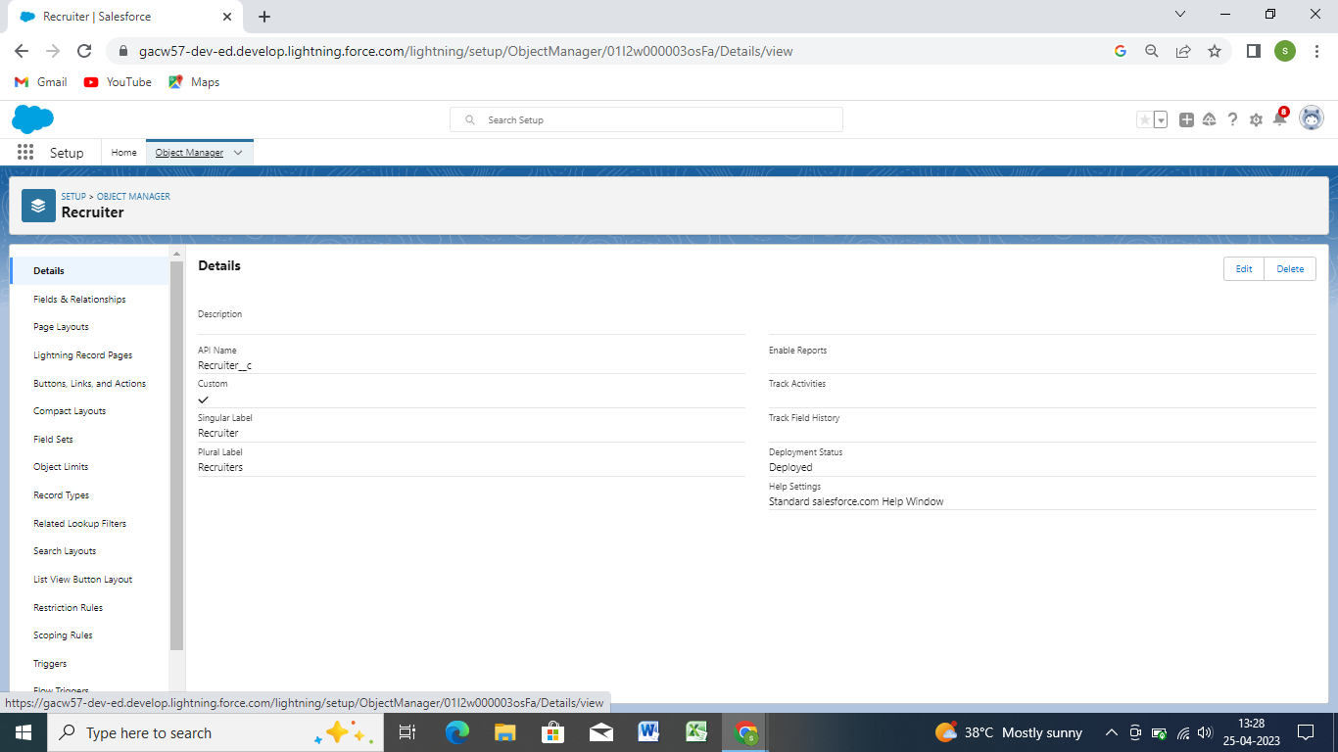

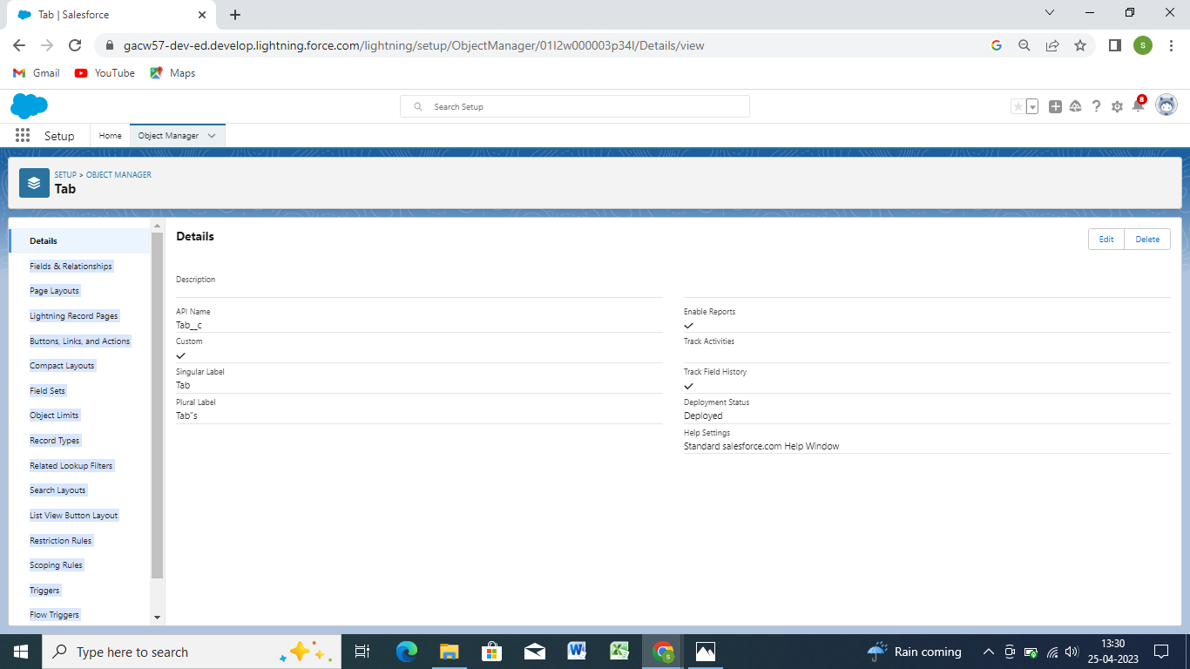

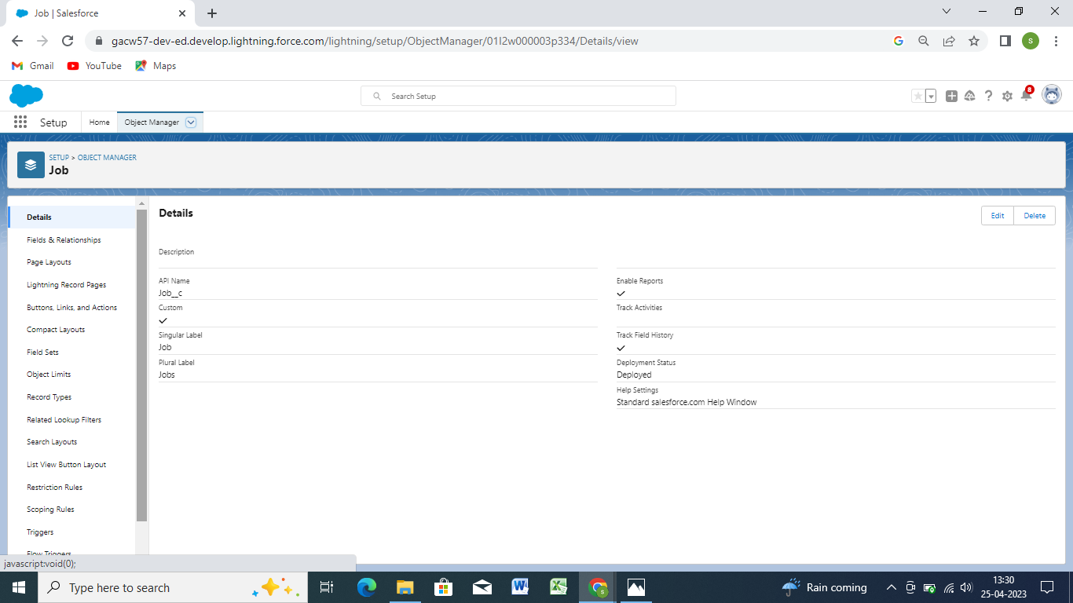

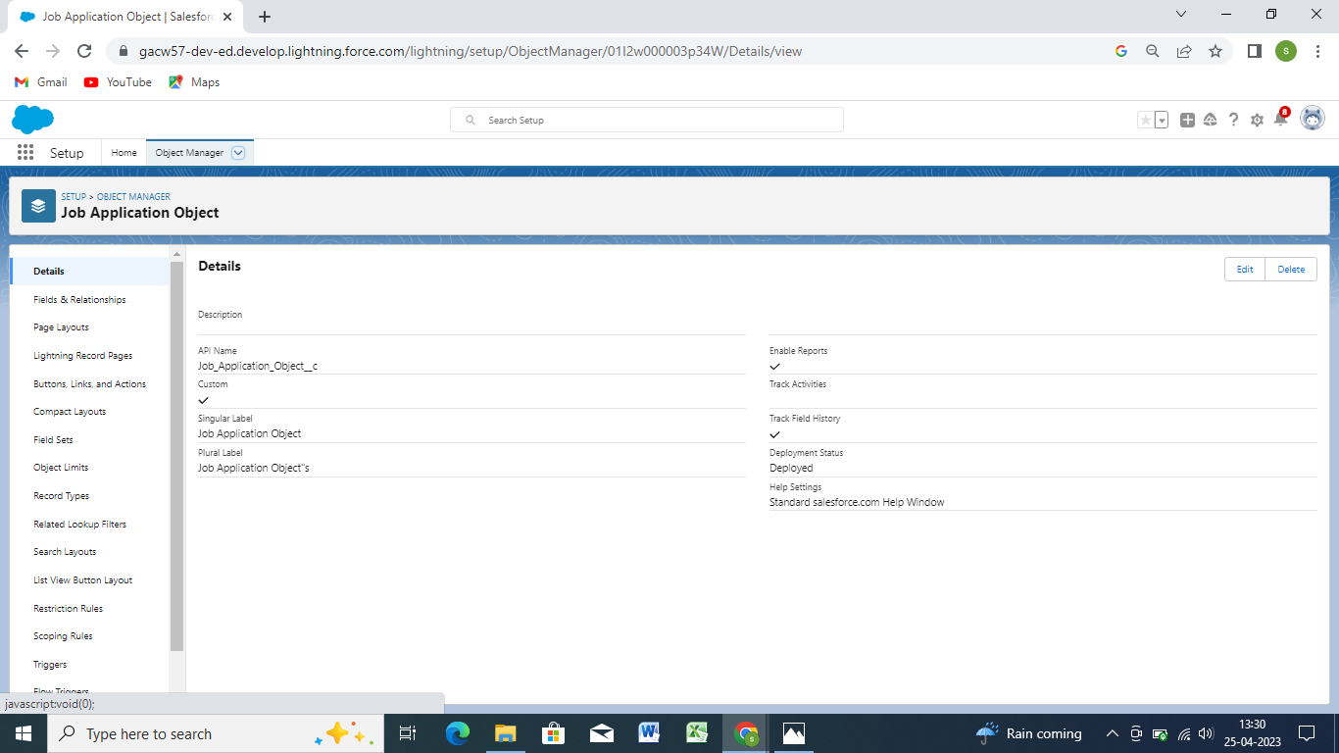

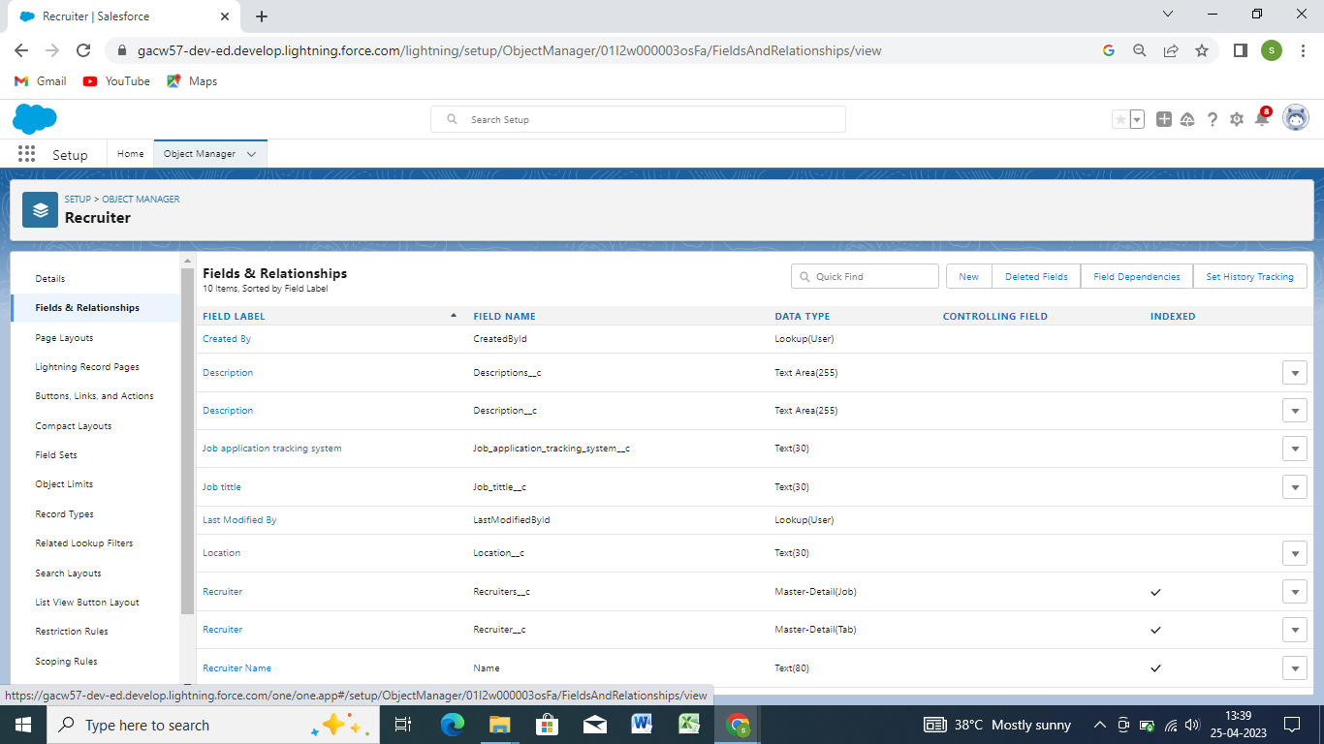

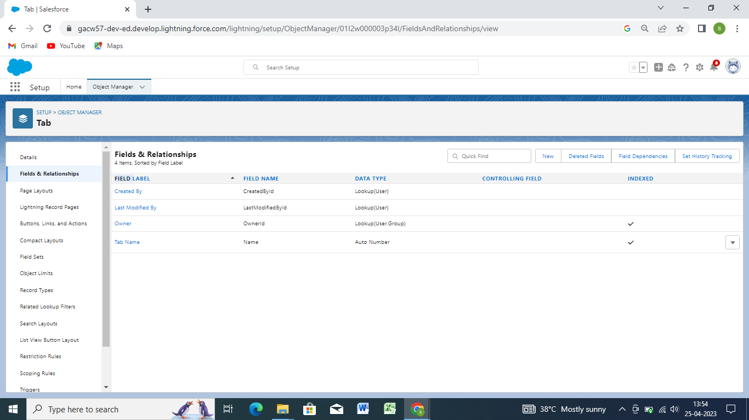

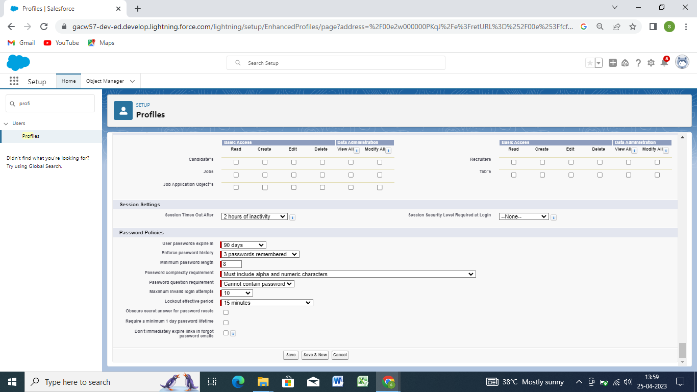

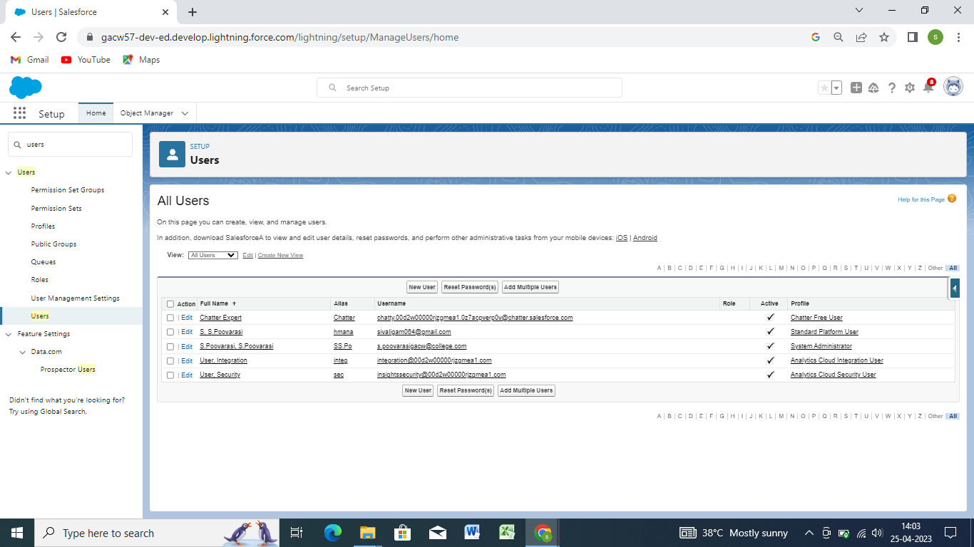

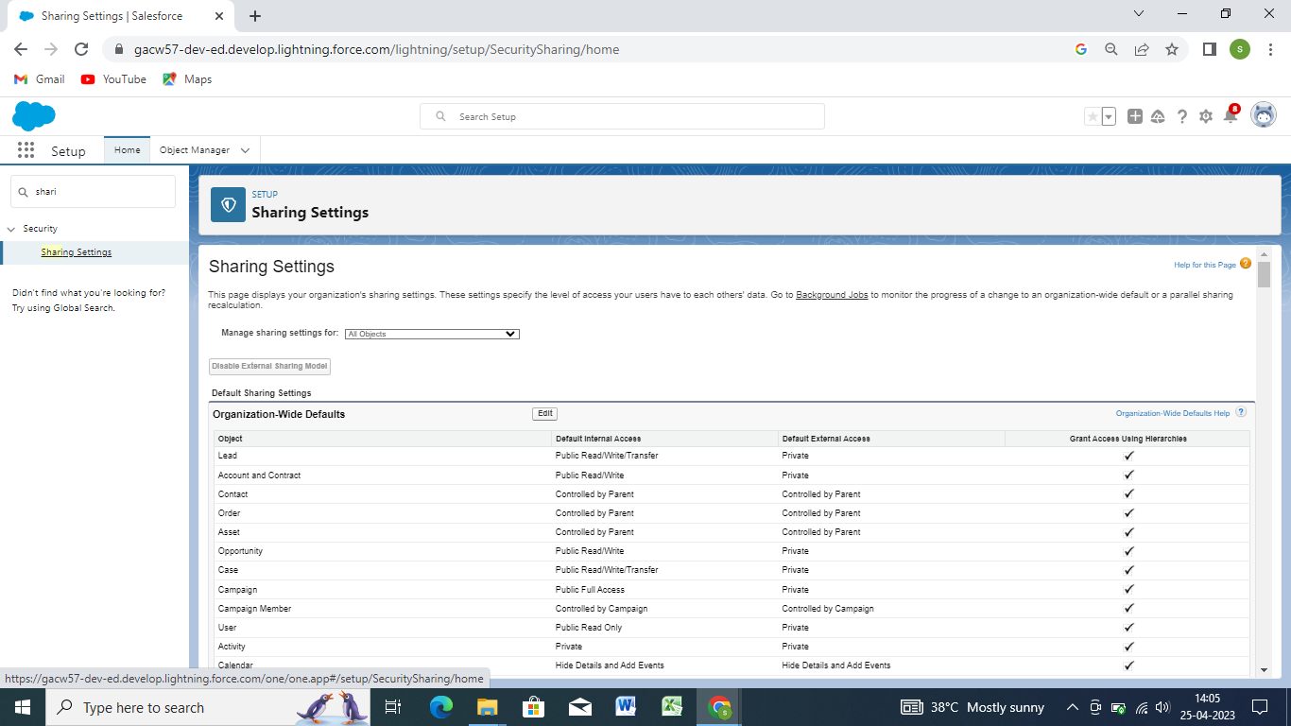

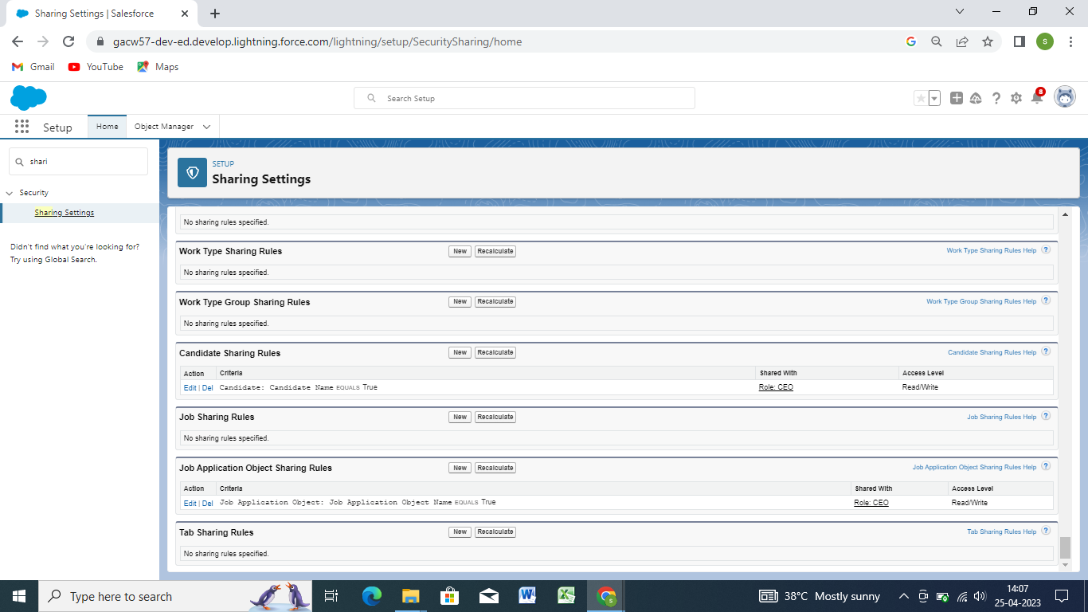

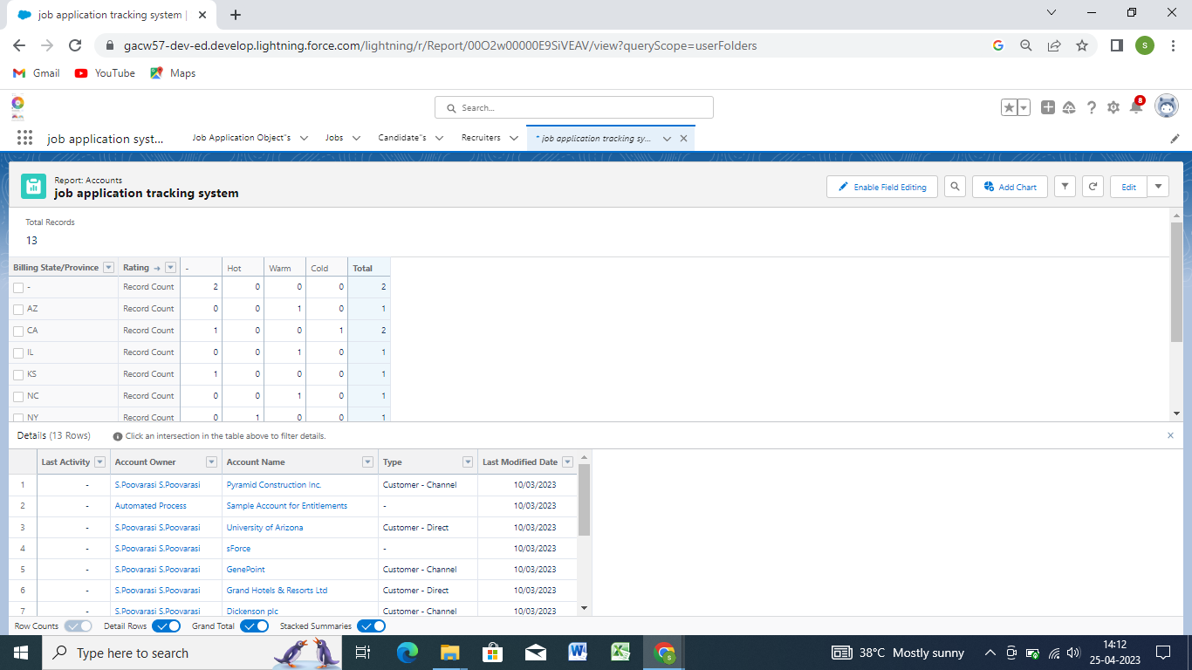

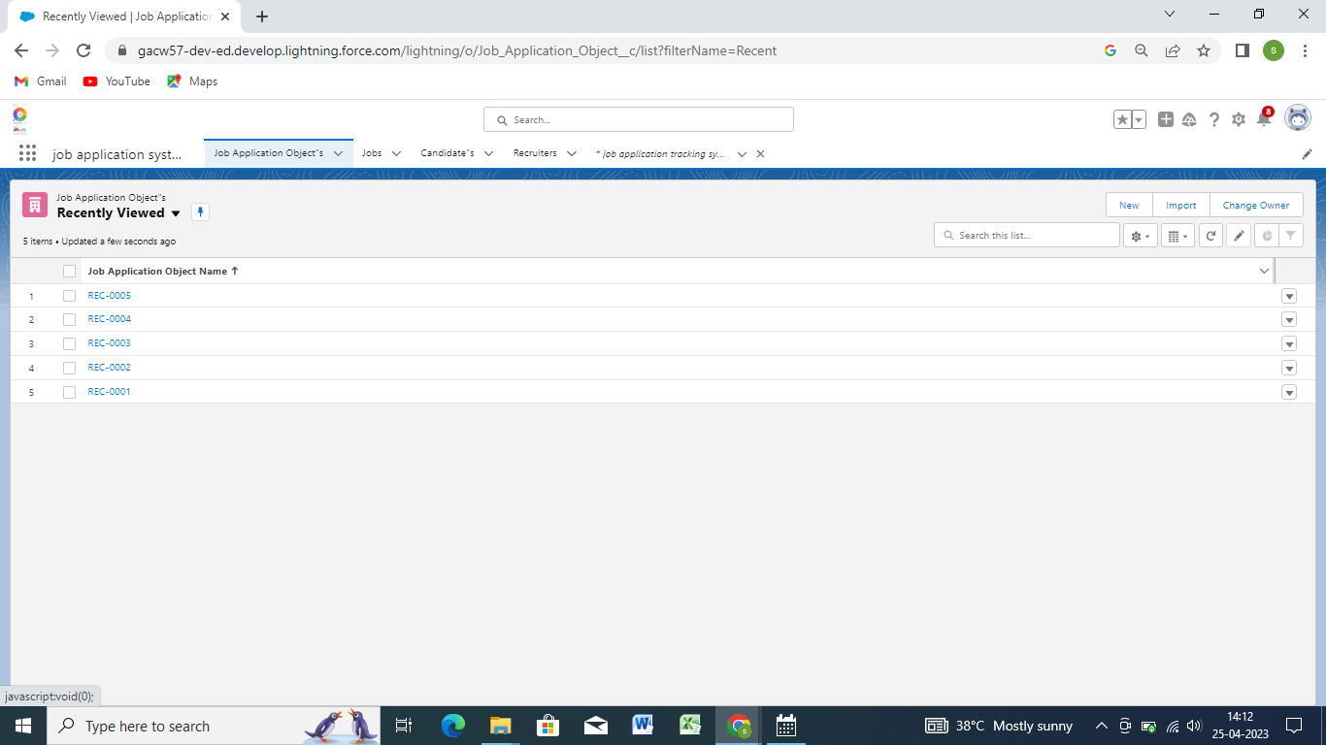

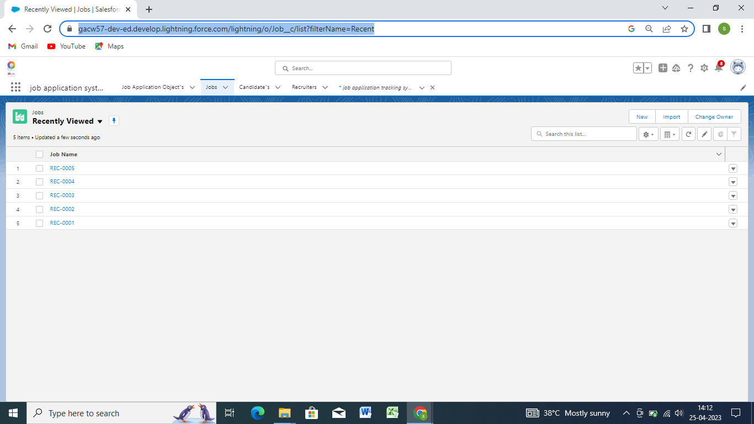

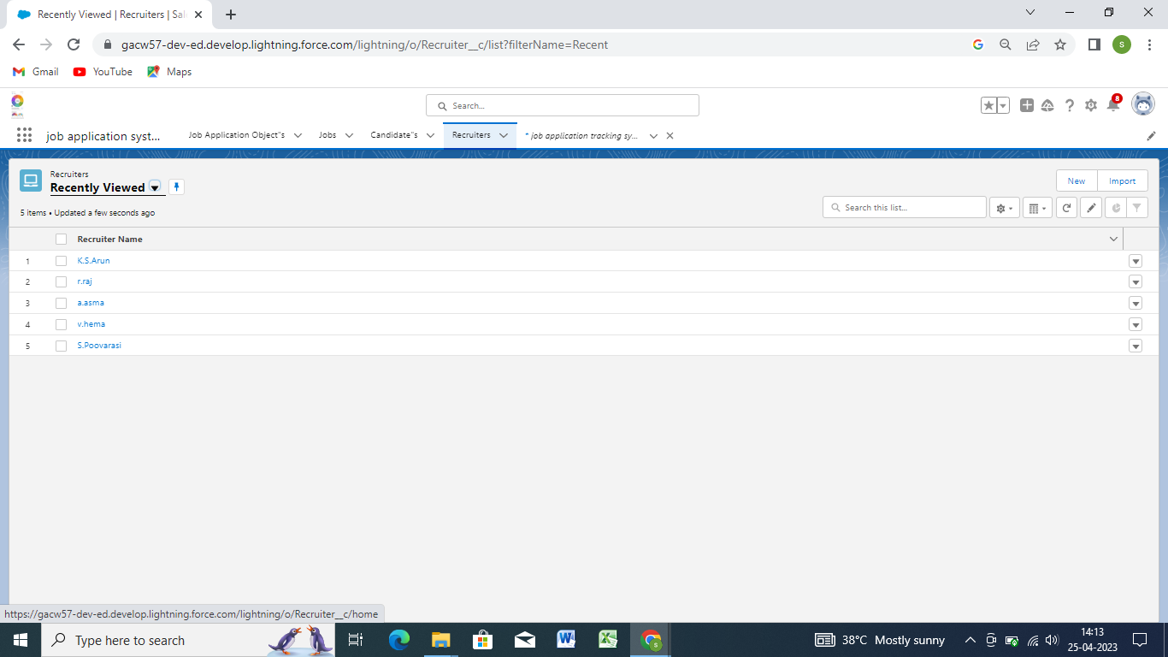

1. **Trailhead Profile Public URL**

Team Lead ( S.Poovarasi) - https://trailblazer.me/id/sspoovarasi

**Team Member 1(P.Shenbagam) https://trailblazer.me/id/kkavinmithilesh**

**Team Member 2 (K.Sneha) -https://trailblazer.me/id/ksnek2**

**Team Member 3( S.Priya) – https://trailblazer.me/id/priya9867**

1. **ADVANTAGES –**  Saves time for value added word ,better overview of application,improved cost –per –hire,improved quality hire

**Reduces time spent on admin tasks,Resume and CV screening,Speeds up the recruitment cycle,Improves the quality of hire,Enhances reporting and compliance.cc**

**DISADVANTAGE-**  A Disadvantage ATS is missing qualified applicants due to wrong keyword selection. Automatic elimination of resumes that software cannot recognize and interpret is another drawback of ATS. An Applicant Tracking System Disadvantages is that they are open to manipulation.

1. **APPLICATIONS**

Stores job candidate information like resumes ,cover letter,reference,and other recruitment and hiring data that HR teams can easily access ana organize

1. **CONCLUSION**

Application Tacking System for recruiters is a very effective hiring solution that most of the successful recruiters utilize because without it ,there is a good chances that your process of moving applications

1. **FUTURE SCOPE**

AN ATS creates opportunities to automatic processes ,increase visibility into the hiring cycle for the entire recruiting team and increase opportunities throughout the candidate journey.